Need a holiday but can’t afford one? We can help!
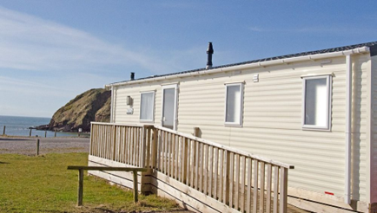
Time to Change (West Cumbria) and Carlisle Diocese Mothers’ Union are working with Seacote Park, St Bees to provide those who need it, a free holiday. The holidays are called Away From it All (AFIA).
If you want to apply yourself or on someone else’s behalf please contact AFIA@carlislediocesemothersunion.org.uk
You can apply for a Sat-Sat or Mon-Fri week, or Fri-Sun weekend
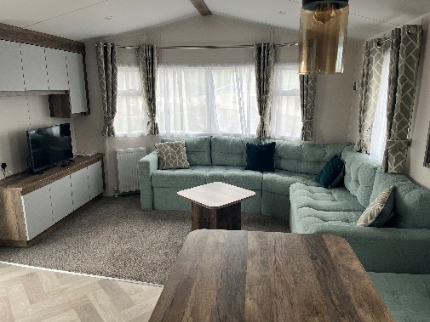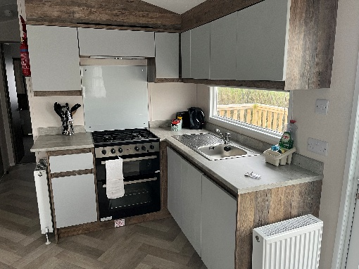
The Caravan: has 2 bedrooms with one double bedroom with toilet and a 2 bedded room. There is a sofa bed in the living room There is another toilet and shower. The caravan is equipped with cooker, microwave and fridge/freezer. Bedding is supplied along with some basic games and toys. A play park and café/shop are both on the beach front.
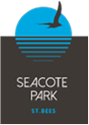 Pease be aware that successful application for a holiday cannot be guaranteed and will depend on demand. We are sorry if this causes upset.
Time to change, West Cumbria (TTC) believes in kindness for all our communities. Our Vision is “Through warmth and kindness, providing help and support to those most in need in our communities”. This is why we have worked together with Carlisle Diocese Mothers Union to offer holidays for families in West Cumbria who are desperately in need of a break away from it all.
Seacote Park is situated beside the most popular beach in West Cumbria and attracts visitors from all parts of Britain and abroad. We are pleased to be associated with Carlisle Diocese Mothers’ Union and Time to Change to welcome families in need, for a caravan holiday. We hope you have a lovely stay and don’t forget to bring your swimming your bathing costume!!

Carlisle Diocese Mothers’ Union (CDMU): is part of an International Christian charity that focuses on the support of families to help build strong relationships and communities, which is why it wanted to work with another like-minded charity. CDMU works with those of all faiths and none. It has been active in Cumbria for over 130 years.

